1. appendToFile



1. cat



1. checksum



1. chgrp

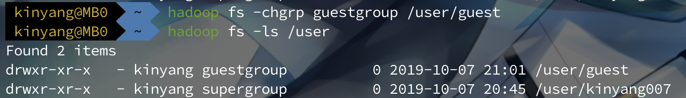

1. chmod



1. chown

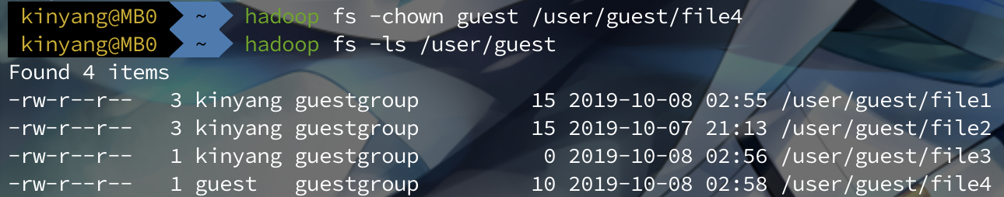

1. copyFromLocal



1. copyToLocal



1. count

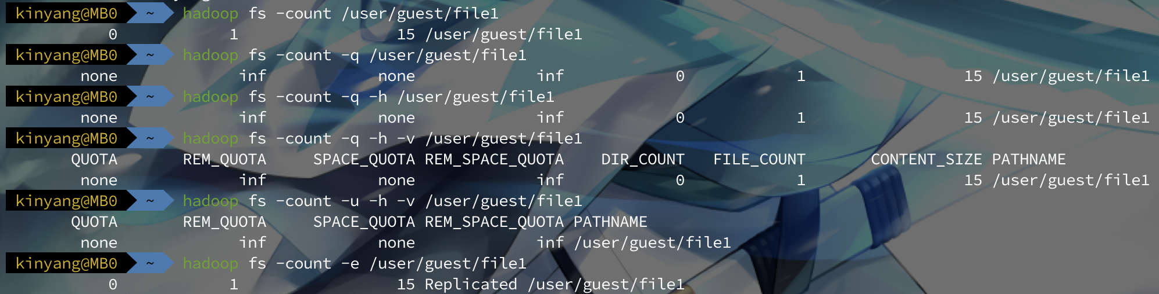

1. cp

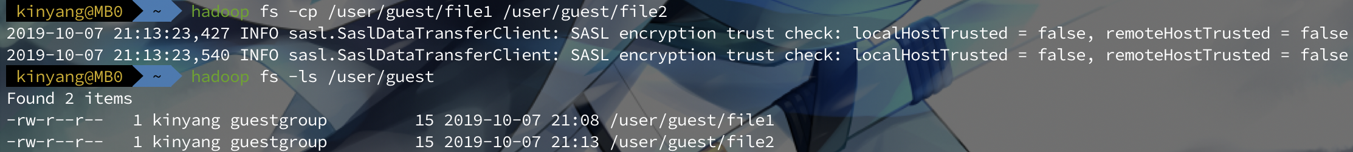

1. createSnapshot



1. deleteSnapshot



1. df

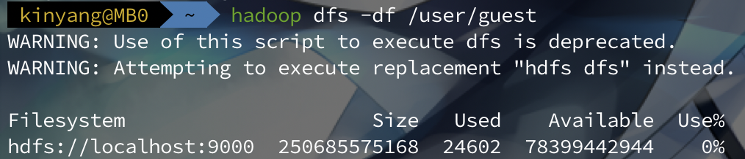

1. du

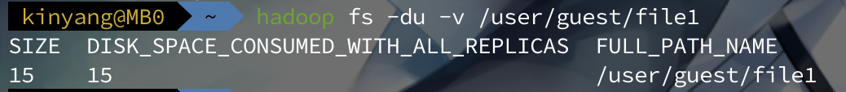

1. dus



1. expunge

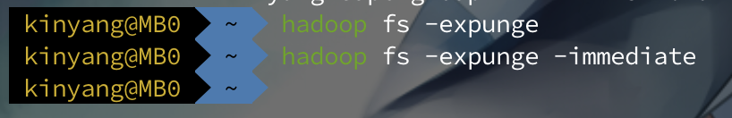

1. find

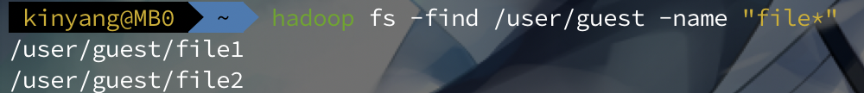

1. get



1. getfacl



1. getfattr



1. getmerge

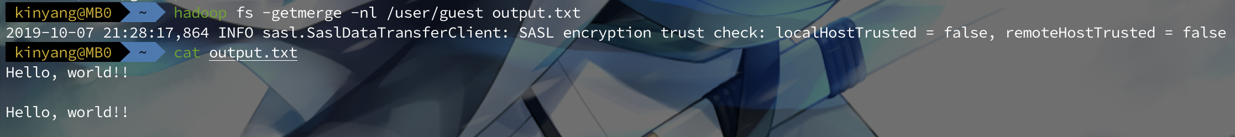

1. head



1. help



1. ls

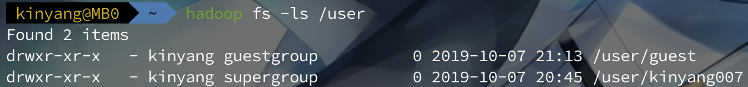

1. lsr

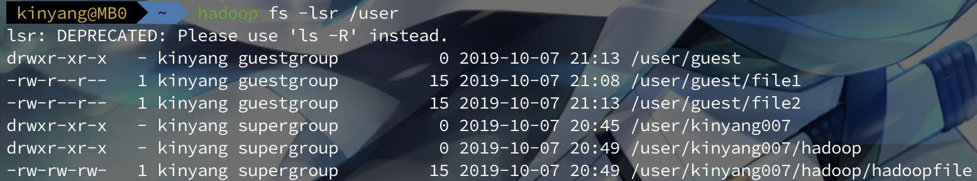

1. mkdir

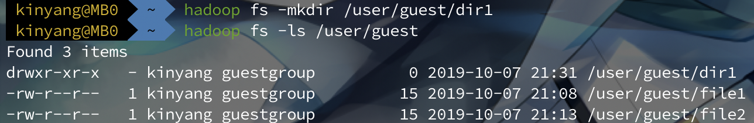

1. moveFromLocal



1. moveToLocal



1. mv

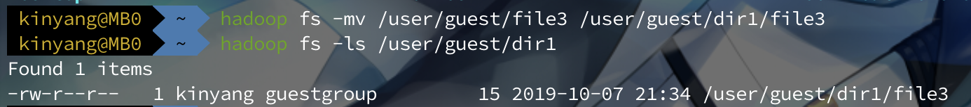

1. put

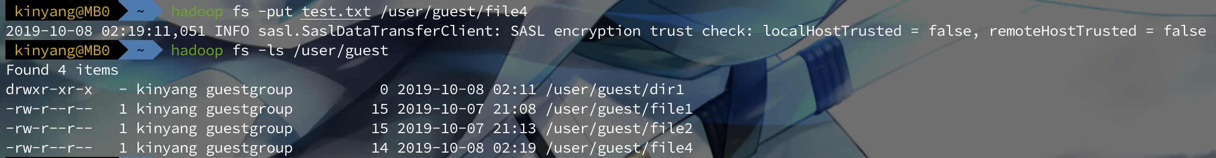

1. renameSnapshot



1. rm



1. rmdir

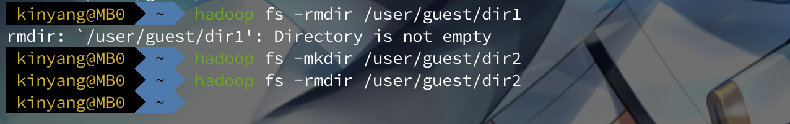

1. rmr

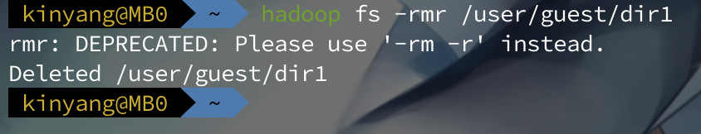

1. setfacl



1. setfattr

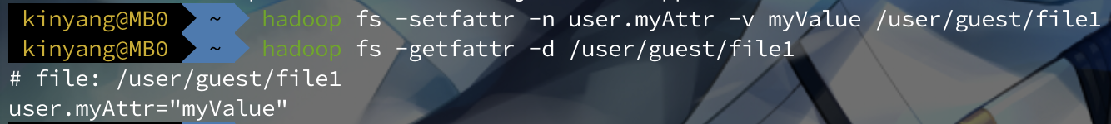

1. setrep



1. stat



1. tail



1. test

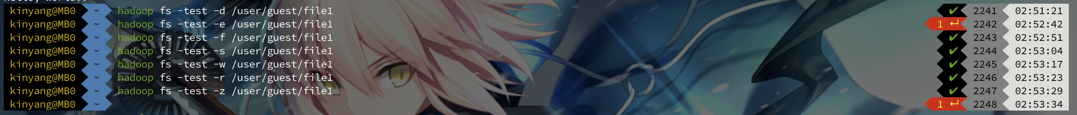

1. text



1. touch



1. touchz

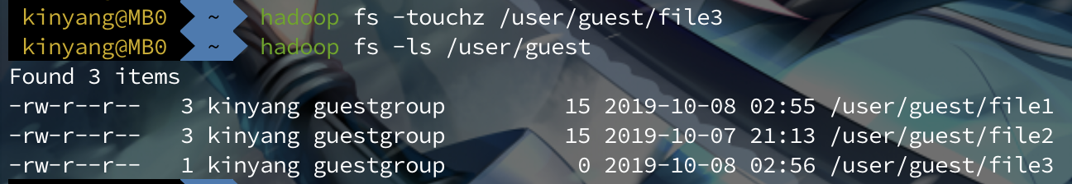

1. truncate

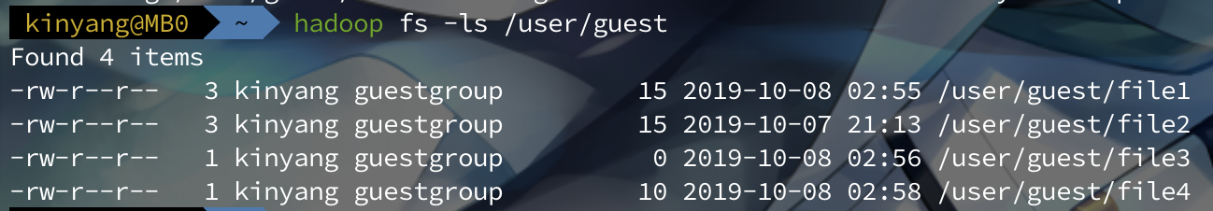

1. usage

